Climate Calculator User’s Manual
The Minnesota Climate Calculator is an Excel-based calculator that estimates greenhouse gas (GHG) emissions from development projects in Minnesota based on user inputs, default assumptions, and emission factors. The Excel-based calculator has dynamic functionality for users to select their project type and input details for each applicable emissions source and phase of the project. For select fields, users can decide whether to use default assumptions and emission factors or override them and provide their own inputs. Based on these selections and inputs, the calculator quantifies the cumulative and annualized GHG emissions from each emissions source and summarizes the results in tables and charts that can be used to respond to answer item 18 of the Environmental Assessment Worksheet (EAW). The calculator also provides qualitative information on mitigation measures and adaptation strategies. The remainder of this user manual is organized as follows:
- Section 1: Getting Started
- Section 2: Calculator Structure
- Section 3: Using the Climate Calculator
- Section 4: Calculator Inputs
- Section 5: Emission Outputs
- Section 6: Mitigation and Adaptation
- Getting Started
The calculator was developed using Microsoft® Excel® for Microsoft 365. While the module should function properly using older versions of Excel, it works best with Excel for Microsoft 365 or later on IBM-PC compatible computers. If a user is using another version of Excel, instructions for opening the module or adjusting settings may vary.

Microsoft Excel Security
If Excel’s default security settings are on, a Security Warning may appear when opening the calculator, indicating that macros are disabled. To enable macros, either click “Enable Content” as shown in Figure D-1 or click “Options” in the security message, select “Enable this content,” then close the welcome message box.
Figure D-1. Microsoft Excel Macro Security Warning
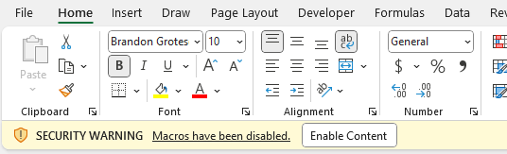
If the Security Warning does not appear, users may need to adjust macro security settings. Exit the spreadsheet, re-launch Excel, and open the calculator. Click the Excel icon, select “Excel Options,” then “Trust Center.” Click “Trust Center Settings,” then “Macro Settings,” and choose “Disable all macros with notification.” Before re-opening the module, right-click the file, select properties, and mark “Unblock” under the “General” tab. Open the module again and enable macros as described above. See Figure D-2 for an example of this setting.
Figure D-2. Microsoft Excel Security Settings for Macros
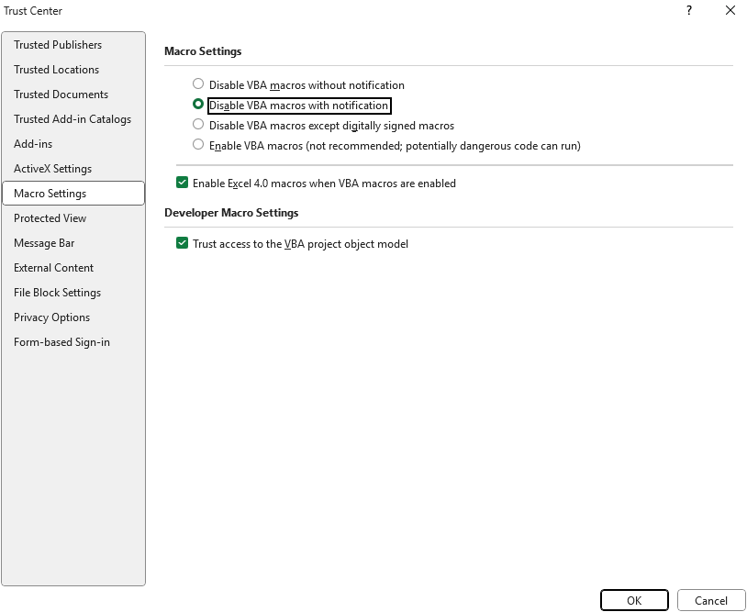

Microsoft Excel Settings
For the calculator to function properly, Excel must be set to automatic calculation. In the Formulas ribbon, select “Calculation Options” and make sure that the box next to the “Automatic” option is checked from the menu. See Figure D-3 for an example of this setting.
Figure D-3. Microsoft Excel Settings for Automatic Calculations
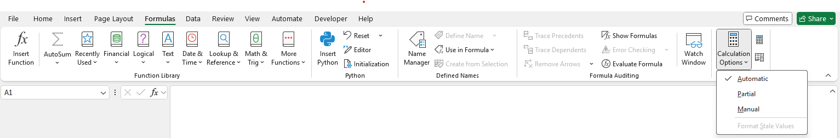
- Calculator Structure
The organization of the calculator is summarized in Table D-1.
Table D-1. Climate Calculator Structure
Tab Name | Contents
Introduction | Summarizes the purpose, scope, and limitations of the calculator. Includes the version number and release date.
User Guide | Includes instructional steps on how to use the calculator, a cell legend, and a table of contents describing the details of each tab.
Project Background | Prompts users to enter basic information about their project, including the project name, category, location, construction start date and duration, the year when the project is expected to be fully operational, the project lifespan, project acreage, building area, and electricity provider. Allows the user to select the preferred unit in which to present results. Based on the project category selected, the calculator specifies which emission sources may apply and give users the option to select and unselect emission sources to quantify.
User Inputs | Prompts users to enter the activity data needed to quantify emissions from the selected emission sources, organized by project phase. Users also have the option to view and override, as desired, select default assumptions and emission factors.
Notes | Allows users to document assumptions, data sources, notes for reviewers, special circumstances or other helpful information specific to their project, organized by project phase and emissions source.
Construction | Shows the calculations for quantifying emissions from each applicable emissions source during the construction phase of the project, drawing on user inputs, assumptions, constants, and emission factors.
Operation | Shows the calculations for quantifying emissions from each applicable emissions source during the operational phase of the project, drawing on user inputs, assumptions, constants, and emission factors.
Results | Provides a summary of cumulative and annualized project-related lifetime emissions by emissions source and project phase.
Charts | Graphically summarizes cumulative and annualized GHG emissions by source.
Mitigation | Identifies potential mitigation measures to reduce GHG emissions, organized by the primary source through which emission reductions are expected.
Quantified Reductions | Quantifies GHG emission reductions from select mitigation measures.
Adaptation | Identifies potential adaptation strategies, organized by climate trend and project characteristics.
Assumptions | Summarizes assumptions, including both activity data and emission factors, that are used in the calculations.
Constants | Lists constants and conversion factors used in the calculations.
Other (Variable Names) | Additional white tabs that document raw data inputs and the interim calculations used to derive the assumptions.
- Using the Climate Calculator
The general process for using the calculator is summarized by the six steps outline in Figure D-4. Instructions and guidance are embedded throughout the calculator to help guide users through this process. Instructional or informational language is found at the top of each tab and/or section and provided in pop-up text boxes for select cells. Additional features of the calculator that support data accuracy, completeness, and usability are discussed further in the remainder of this section.
Figure D-4. Overview of the Process for Using the Climate Calculator

Formatting: Formatting is used throughout the calculator to help users understand where to enter data and what the data in each cell represents. The cell legend used in the calculator is shown in Table D-2.
Table D-2. Climate Calculator Cell Legend
Legend | Criteria
 | Yellow cells are data input fields.
 | Blue cells are headings and are not editable.
 | White cells are lists or constants and are not editable.
 | Green cells are calculated fields and are not editable.
 | Light green cells are calculated fields for interim calculations and are not editable.
 | Gray cells are assumptions and are not editable.
 | Black cells are for emissions sources that are not applicable and are not calculated.
Navigation: As shown in Figure D-5, the calculator is organized into informational tabs (shaded in dark blue) input tabs (shaded in yellow), calculation tabs (shaded in green), mitigation and adaptation tabs (shaded in blue), and assumptions and constants tabs (shaded in light blue). Users can navigate through the sections of the calculator by selecting the navigation arrows at the top of each tab or clicking directly on the tab name at the bottom of Excel. Users can navigate to the top of each tab by selecting the return to top buttons at the bottom of tabs. On the User Inputs, Construction, and Operation tabs, users can select the green boxes at the top to navigate to specific sections of a tab. An example of the navigation features on the User Inputs tab is shown in Figure D-6.
Figure D-5. Tab Organization and Coloring
Figure D-6. Navigation Features on the User Inputs Tab
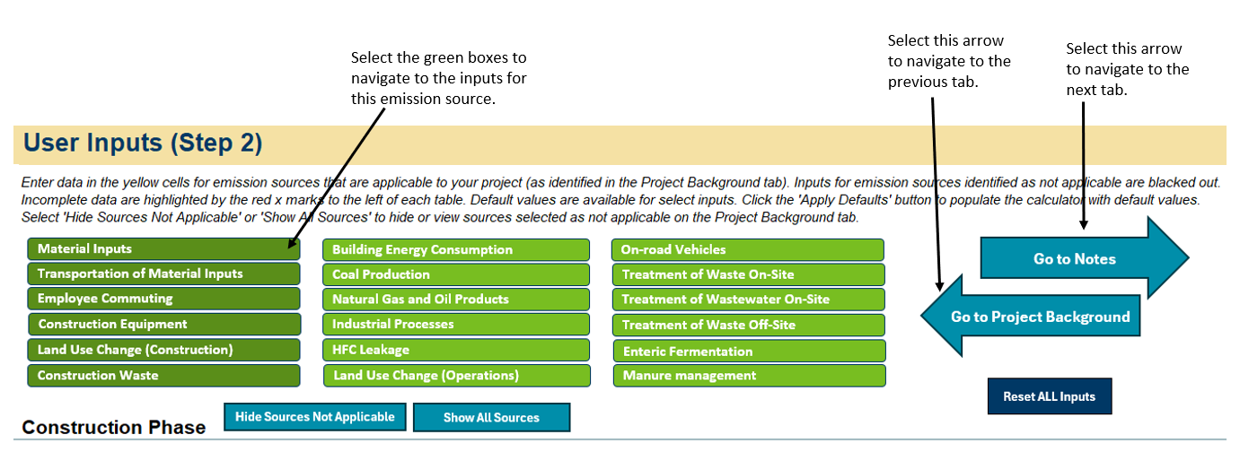
Applying Defaults: Default assumptions are available for select user inputs. Default data are displayed in gray cells and link to values summarized on the Assumptions tab. For inputs where default data are available, an “Apply Defaults” button is included next to these inputs to allow users to easily populate the calculator with default values. A ‘Reset ALL Inputs’ button is also included to remove all inputs, both those that are defaults and user-provided inputs, from each emission source. Note that the “Reset” button will clear all user inputs from the input fields, even manually entered or edited values. An example of the default and reset buttons on the User Inputs tab is shown in Figure D-7.
Figure D-7. Example of Applying Defaults and Reset Buttons for an Emission Source on the User Inputs Tab
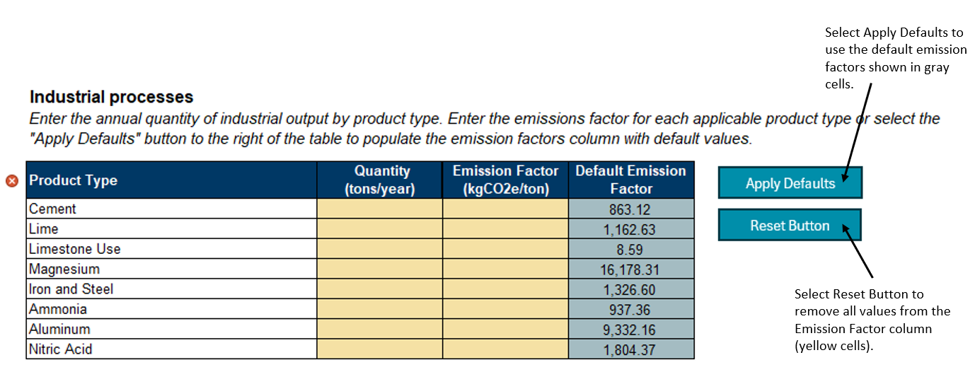
Shading and Hiding: Gray shading with black dashed lines are used throughout the calculator when values are not applicable based on prior selections made by the user. On the User Inputs tab, users may choose to hide all these rows for sources that are identified as not applicable by selecting the “Hide Sources Not Applicable” button at the top of the tab. Rows for non-applicable sources are automatically hidden in the Results and Charts tabs. See Figure D-8 for an example of these features.
Figure D-8. Example of Shading and Hiding for Not Applicable Emissions Sources
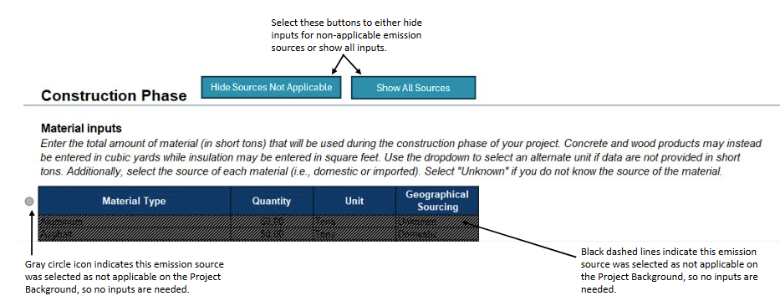
Data Validations: Data validations are built into user input fields to help ensure data quality and accuracy. Validations include value ranges, drop-down lists, and formatting restrictions. A pop-up message will appear if you try to enter a nonvalid value into a user input field. An example of a data validation pop-up message is shown in Figure D-9.
Figure D-9. Example of Data Validation on the User Inputs Tab
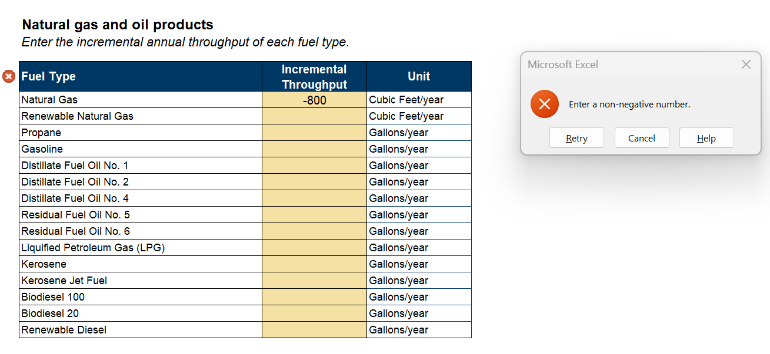
Data Checks: Data checks are used to alert users to incomplete or incorrectly entered data. Checker icons are included next to each required field or table. A red “x” icon will appear next to a field if it is left blank, and a green check icon will appear if the field has been populated. Checkers are not included for fields where inputs are optional. Red text will also display if inputs are entered incorrectly (see Figure D-10). Furthermore, if all inputs are not provided on the Project Background tab, a pop-up message will be displayed when users navigate to the User Inputs tab. Similarly, if not all user inputs are provided for emissions sources selected as applicable, a pop-up message and red error text will also appear when users navigate to the Results tab (see Figure D-11).
Figure D-10. Example of Error Checkers for Land Use Change (Construction) User Inputs
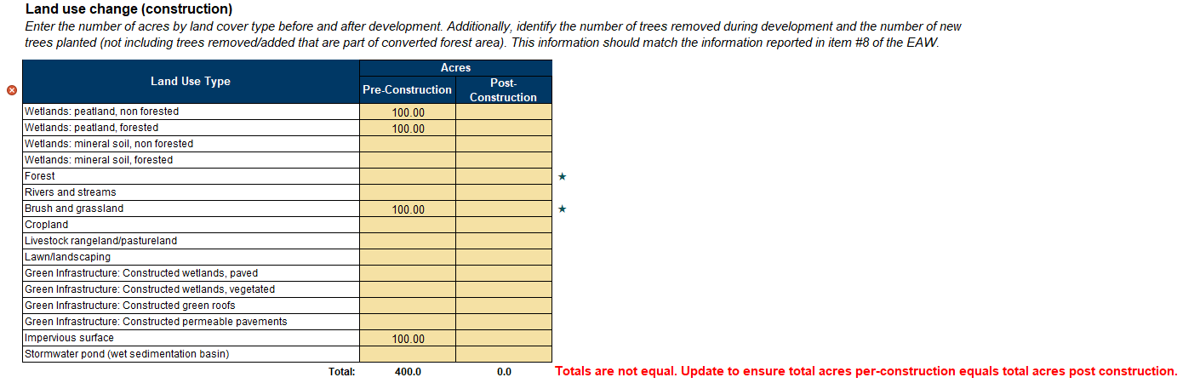
Figure D-11. Example of Data Validation on the Results Tab
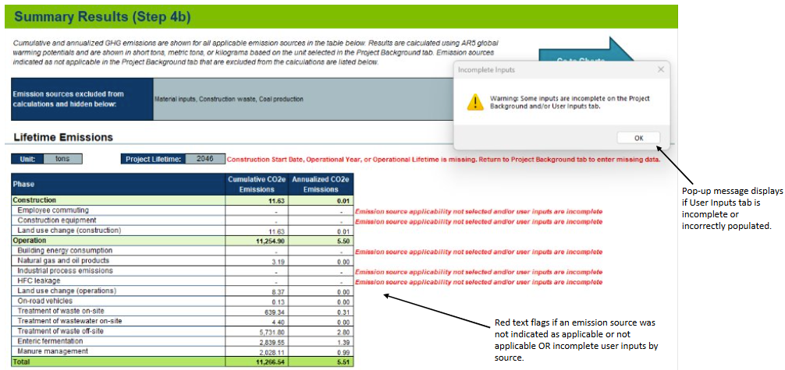

- Calculator Inputs
Users of the calculator are required to enter data into the Project Background and User Inputs tabs. Detailed guidance on when and what to enter in each field are provided by tab and subsection below.

Project Background Tab
Project Information: Users are required to provide information on the type, timeframe, and size of their proposed project as well as energy source information, as available. Results will not calculate if certain fields are left blank, as highlighted by red x marks. Project information inputs, including information on the field type, data validations, availability of default assumptions, and use within the calculator, are detailed in Table D-3.
Table D-3. Project Information User Inputs on the Project Background Tab
Input | Input Type | Data validation | Default Assumption | Description/Use
Project Name | Text | NA | NA | This input is optional.
Project Category (primary) | Drop-down selection | Must match value from drop-down list. Checker indicates if cell is left blank. | NA | Used for default emission source applicability.
Project Category (secondary) | Drop-down selection | Must match value from drop-down list. | NA | Used for default emission source applicability.
Location (County) | Drop-down selection | Must match value from drop-down list. Checker indicates if cell is left blank. | NA | Location where the project will be built. Used for default treatment of waste off-site assumptions.
Construction Start Date | mm/dd/yyyy | Validation for date format. Checker indicates if cell is left blank. | NA | The anticipated start date of project construction. Used to calculate project lifetime and cumulative emissions. Used to determine the annually variable emission factors for calculating emissions from the transportation of material inputs and construction electricity consumption.
Operational Year | yyyy | Validation for date format. Checker indicates if cell is left blank. | NA | The year in which the project is expected to become operational. Used to calculate project lifetime and cumulative emissions. Used to determine the annually variable emission factors for calculating emissions from on-road vehicles and operational electricity consumption.
Operational Lifetime (Years) | Whole number | Validation for number between 1 and 60. Checker indicates if cell is left blank. | NA | The anticipated operational lifetime of the project. Used to calculate project lifetime and cumulative emissions.
Building Construction Project | Drop-down selection | Must match value from drop-down list. | Calculator is defaulted to Yes. | A building construction project refers to the construction of a building like an office or house. In contrast, a linear construction project describes a project where construction progresses along a continuous line, like a road, pipeline, or railway. Determines if construction stage duration inputs are needed and the applicability of the default assumptions.
Construction Stage Durations (Days) | Whole number | Must be a whole number greater than 0. Checker indicates if all cells are left blank. | Defaults vary based on project acreage and are only applicable to building construction projects due to source data. | Duration of each construction stage. Used for employee commuting and construction equipment calculations.
Total Project Acreage | Decimal number | Must be a decimal number greater than 0. Checker indicates if cell is left blank. | NA | Area of land that is disturbed during project construction or operation. Used to calculate construction stage duration defaults.
Area by building type (sq ft) | Decimal number | Must be a decimal number greater than 0. Checker indicates if all cells are left blank for building construction projects. | NA | Building area constructed by building type. Used to calculate emissions from building energy consumption and HFC leakage.
Electricity Provider | Drop-down selection | Must match value from drop-down list. | Calculator is defaulted to Grid Average. | Used to determine the electricity emission factors for building energy consumption calculations.
Portion of Building Electricity Consumption to be Generated On-Site via Renewables or Supplied through the Purchase of Renewable Energy Credits (RECs)* | Percent | Data validation for percent between 0 and 100. | Calculator is defaulted to 0. | Identifies the portion of building electricity consumption provided by renewable sources via direct purchase or on-site generation. Value may not be greater than 100%. Used to calculate electricity emissions from building energy consumption.
Portion of Building Natural Gas Consumption to be Supplied from Renewable Sources* | Percent | Data validation for percent between 0 and 100. | Calculator is defaulted to 0. | Identifies the portion of building natural gas consumption provided by renewable sources via direct purchase or on-site generation. Used to calculate natural gas emissions from building energy consumption.
*Input for mitigation measure quantification.
Calculator Calculations Preferences: Users can specify their preferred unit in which to present emissions in the Results tab. The drop-down list allows users to select from the following options: Tons (short tons), MT (metric tons), or Kg (kilograms).
Applicable Emission Sources: Information on whether an emissions source is potentially applicable to your project will automatically populate based on the primary and secondary project category selected in the Project Information section. Users can apply default selections by clicking the “Apply Defaults” or choose which emission sources to include by selecting “Yes” or “No” in the drop-down menu next to each emissions source. A selection must be made for each emissions source. If “No” is selected, fields applicable to that emissions source will be shaded gray with black dashed lines and/or hidden in subsequent tabs of the calculator and no emissions from that source will be included in the results.

User Inputs Tab
On the User Inputs tab, fields that are not applicable to the selected project type will be shaded gray with black dashed lines to align with the selections on the Project Background tab. Users can hide all inputs for emissions sources that are not appliable to their project by selecting the “Hide Sources Not Applicable” button at the top of this tab. User input cells are shaded yellow so it is clear which cells require data. Default assumptions and emission factors are provided in gray and can be populated by selecting the “Apply Defaults” buttons next to each emission source user input table. A “Reset ALL Inputs” button is included if users would like to clear all user inputs from this tab. Checker icons throughout the tab are color coded as follows:
- A gray circle icon if the emission source is excluded from the calculations
- A red x icon if the emission source is applicable but required data inputs are missing
- A green check icon if the emission source is applicable and all required inputs are provided
- A blue star  icon if the input is for mitigation measure quantification

Material Inputs: If material inputs and transportation of material inputs are applicable to the project, a user is required to enter the inputs described in Table D-4.
Table D-4. User Inputs for Material Inputs
Input | Input Type | Data validation | Default Assumptions | Description/Use
Quantity | Decimal number | Must be a decimal number equal to or greater than 0. Red checker appears if the sum of all inputs equals 0. For individual materials, users can leave the quantity blank or 0. | NA | Total amount of material that will be used during construction. These quantities are also used to calculate default construction waste material quantities.
Unit | Drop-down selection | Must match value from drop-down list. | Calculator is defaulted to tons. | Identifies the unit of measure for the provided material quantity.
Geographical Sourcing | Drop-down selection | Must match value from drop-down list. | Calculator is defaulted to “Unknown”, except for Asphalt and Concrete, which are only sourced domestically. | Identifies the source of the material input. Select "Unknown" if you do not know the source of the material. Used to determine the distance traveled by mode for the transportation of material inputs.
Employee Commuting: If employee commuting is applicable to the project, a user is required to enter the inputs described in Table D-5.
Table D-5. User Inputs for Employee Commuting
Input | Input Type | Data validation | Default Assumptions | Description/Use
Daily Average Number of Employees Commuting | Whole number | Must be a whole number equal to or greater than 0. Red checker appears if sum of all values equals 0. For individual construction stages, users can leave cell blank or 0. | NA | Average number of employees that will commute to the construction site during each phase of construction.
Average One-Way Commute Length | Decimal number | Must be a decimal number greater than 0. Value must be populated or red checker will appear. | Yes | Average one-way commuter distance in miles.
Percent of Employees by Transportation Mode* | Percent | Must be between 0 and 100 for each mode. Total across modes must sum to 100%. Red checker and text will appear if total does not equal 100%. | Yes | Percent of employees that commute by each transportation mode.
*Input for mitigation measure quantification.
Construction Equipment: If construction equipment is applicable to the project, a user is required to enter the inputs described in Table D-6 depending on the user-selected approach.
Table D-6. User Inputs for Construction Equipment
Input | Input Type | Data validation | Default Assumptions | Description/Use
Equipment Use Approach
Fuel type by equipment type* | Drop-down selection | Must match value from drop-down list. | Calculator is defaulted to diesel. | Determines the emission factor used for calculating emissions from construction equipment.
Number of Hours per Day by Construction Stage for each equipment type | Decimal number | Must be a decimal number equal to or greater than 0. Users only need to enter values for equipment types and construction stages relevant to their project. | Yes. Defaults are only applicable to building construction projects and values are dependent on the user-provided project acreage. | Total number of hours each equipment type is used per day by construction phase. Total hours should account for multiple pieces of equipment being used each day.
Fuel Consumption Approach
Consumption by Fuel Type* | Decimal number | Must be a decimal number greater than 0. Users only need to enter values for fuel types relevant to their project. | NA | Total consumption by fuel type in the designated units. Total consumption should account for total consumption by all construction equipment during the construction phase of the project.
*Input for mitigation measure quantification.
Land Use Change (Construction): If land use change during construction is applicable to the project, a user is required to enter the inputs described in Table D-7. This information should match the information reported in Item #8 of the EAW.
Table D-7. User Inputs for Land Use Change During Construction
Input | Input Type | Data validation | Default Assumptions | Description/Use
Pre-construction acreage by land use type | Decimal number | Must be a decimal number equal to or greater than 0. Red checkers will appear if total pre-construction acreage does not equal post-construction acreage. | NA | Number of acres by land cover type prior to construction.
Post-construction acreage by land use type* | Decimal number | Must be a decimal number equal to or greater than 0. Red checkers will appear if total post-construction acreage does not equal pre-construction acreage. | NA | Number of acres by land cover type after construction.
Number of mature trees removed | Whole number | Must be a whole number equal to or greater than 0. This input is optional. | NA | Number of trees removed during construction, not including trees removed as part of forest conversion.
Number of new trees planted* | Whole number | Must be a whole number equal to or greater than 0. This input is optional. | NA | Number of new trees planted after development, not including trees planted as part of reforestation.
*Input for mitigation measure quantification.
Construction Waste: If construction waste is applicable to the project, a user is required to enter the inputs described Table D-8.
Table D-8. User Inputs for Construction Waste
Input | Input Type | Data validation | Default Assumptions | Description/Use
Quantity of materials by material type | Decimal number | Must be a decimal number equal to or greater than 0. Red checker appears if the sum of all values equals 0. | Yes. Based on inputs entered under the Material Inputs section. Calculated by multiplying the user-provided material quantities by the assumed loss rate of each material type. No default available for mixed C&D waste. | Total amount of waste generated during construction in short tons. Users may also enter a quantity for mixed C&D waste generated to account for other waste not covered by material-specific values.
Building Energy Consumption: If building energy consumption is applicable to the project, a user is required to enter the inputs described in Table D- 9 depending on the user-selected approach.
Table D-9. User Inputs for Building Energy Consumption
Input | Input Type | Data validation | Default Assumptions | Description/Use
Energy Intensity Approach
Energy intensity by building type | Decimal number | Must be a decimal number equal to or greater than 0. Red checker appears if no values are added for building types with areas greater than 0. | Yes. No defaults are available for Other Building Area.* | The annual amount of energy consumed (in Btu) on average by fuel source per building square foot.
Fuel Consumption Approach
Fuel consumption by fuel type | Decimal number | Must be a decimal number equal to or greater than 0. | NA | The annual amount of energy consumed by buildings by fuel type in the designated units.
* For industrial buildings, industry-specific default values are also calculated and may be used in place of the default provided.
Coal Production: If coal production is applicable to the project, a user is required to enter the inputs described in Table D-10.
Table D-10. User Inputs for Coal Production
Input | Input Type | Data validation | Default Assumptions | Description/Use
Incremental production by coal type | Decimal number | Must be a decimal number equal to or greater than 0. Red checker appears if the sum of all inputs equals 0. For individual coal types, users can leave the quantity blank or 0. | NA | Incremental amount of coal by type that is delivered and combusted as a result of the project in tons per year.
Natural Gas and Oil Products: If natural gas and oil products are applicable to the project, a user is required to enter the inputs described in Table D-11.
Table D-11. User Inputs for Natural Gas and Oil Products
Input | Input Type | Data validation | Default Assumptions | Description/Use
Incremental throughput by fuel type | Decimal number | Must be a decimal number equal to or greater than 0. Red checker appears if the sum of all inputs equals 0. For individual fuel types, users can leave the quantity blank or 0. | NA | Incremental amount of each fuel type in cubic feet or gallons per year, depending on the fuel, that is delivered and combusted as a result of the project.
Percent reduction in leakage and venting emissions for natural gas* | Percent | Must be between 0 and 75%. No checkers as this input is optional. | Yes. Calculator is defaulted to 0. | If mitigation strategies are to be adopted to reduce natural gas leakage and venting, users may enter the anticipated percent reduction relative to the default emissions. This value is used to calculate the adjusted leakage and venting emissions.
*Input for mitigation measure quantification.
Industrial Processes: If industrial processes are applicable to the project, a user is required to enter the inputs described in Table D-12.
Table D-12. User Inputs for Industrial Processes
Input | Input Type | Data validation | Default Assumptions | Description/Use
Quantity of industrial outputs by product type | Decimal number | Must be a decimal number equal to or greater than 0. Red checker appears if the sum of all inputs equals 0. For individual products, users can leave the quantity blank or 0. | NA | Annual quantity of industrial output by product type in tons per year.
Emission factors for each applicable product type | Decimal number | Must be a decimal number greater than 0. Red checkers will appear if no value is provided for product types with a quantity greater than 0. | Yes | Emissions (in kgCO₂e) associated with the production of one ton of output.
HFC Leakage: If HFC leakage is applicable to the project, a user is required to enter the inputs described in Table D-13.
Table D-13. User Inputs for HFC Leakage
Input | Input Type | Data validation | Default Assumptions | Description/Use
Percent of building area utilized by building type | Percent | Must be between 0 and 100% for applicable building types. Red checkers will appear if no input is provided for building types with an area greater than 0. | Yes. Default is 100% for all building types. | Portion of the building area by building type that utilizes air conditioning and/or refrigeration equipment. Building area based on the building square footage data entered in the Project Background tab.
Refrigerant type by building and equipment type* | Drop-down selection | Must match value from drop-down list. Red checker will appear if no value is selected. | Yes | Refrigerant type determines the GWP used in the emissions calculation.
*Input for mitigation measure quantification.
Land Use Change (Operation): If land use change during operation is applicable to the project, a user is required to enter the inputs described in Table D-14.
Table D-14. User Inputs for Land Use Change During Operations
Input | Input Type | Data validation | Default Assumptions | Description/Use
Post-operation acres by land use type | Decimal number | Must be a decimal number equal to or greater than 0. Red checkers will appear if total post-operation acreage does not equal post-construction acreage. | NA | Number of acres by land cover type after project operation.
On-Road Vehicles: If on-road vehicles are applicable to the project, a user is required to enter the inputs described in Table D-15.
Table D-15. User Inputs for On-Road Vehicles
Input | Input Type | Data validation | Default Assumptions | Description/Use
Additional VMT by speed bin | Decimal number | Must be a decimal number equal to or greater than 0. Red checker appears if the sum of all inputs equals 0. For individual speed bins, users can leave the quantity blank or 0. | NA | Additional VMT each year as a result of the project. Users may enter additional VMT for the fleet average and by speed bin, if known.
Treatment of Waste On-Site: If treatment of waste on-site is applicable to the project, a user is required to enter the inputs described in Table D-16.
Table D-16. User Inputs for Treatment of Waste On-Site
Input | Input Type | Data validation | Default Assumptions | Description/Use
Waste Treatment Practice | Drop-down selection | Must match value from drop-down list. Red checker will appear if no practices are selected. | NA | The type of waste treatment practice used by the project. Up to three practices may be selected.
Quantity of Waste Treated | Decimal number | Must be a decimal number greater than 0. Red checkers will appear if no quantities are provided and if a selected waste treatment practice is missing a quantity input. | NA | Amount of waste the project is anticipated to treat on-site in short tons per year.
Treatment of Wastewater On-Site: If treatment of wastewater on-site is applicable to the project, a user is required to enter the inputs described in Table D-17. Only inputs for municipal wastewater treatment of industrial wastewater treatment is required.
Table D-17. User Inputs for Treatment of Wastewater On-Site
Input | Input Type | Data validation | Default Assumptions | Description/Use
Population served by treatment plant | Whole number | Must be a whole number equal to or greater than 0. Red checker will appear if this cell and the production quantity is left blank or 0. | NA | Population served by the municipal wastewater treatment plant.
Wastewater treatment system type | Drop-down selection | Must match value from drop-down list. Red checker will appear if no system type is selected. | NA | Used to determine methane correction factor and direct N₂O emissions factor.
Product type | Drop-down selection | Must match value from drop-down list. Red checker will appear if no product type is selected and the population served is left blank or 0. | NA | Product type for industrial wastewater. Only one type may be selected.
Production | Decimal number | Must be a decimal number equal to or greater than 0. Red checker will appear if no production value is entered and the population served is left blank or 0. | NA | Anticipated production output of the industrial wastewater plant for the selected product type in metric tons per year.
Treatment of Waste Off-Site: If treatment of waste off-site is applicable to the project, a user is required to enter the inputs described in Table D-18.
Table D-18. User Inputs for Waste Off-Site
Input | Input Type | Data validation | Default Assumptions | Description/Use
Quantity of activity | Whole number | Must be a whole number equal to or greater than 0. Red checker appears if the sum of all inputs equals 0. | NA | Number of households, commercial, industrial, or institutional employees, and visitors per year at public venues.
Waste generation rate by activity | Decimal number | Must be a decimal number equal to or greater than 0. Red checker appears if no values are added for activities with quantities greater than 0. | Yes | Waste generation rate in pounds per household per day, employee per day, or pounds per visitor, depending on the activity.
Percent of waste by waste treatment practice* | Percent | Must be between 0 and 100%. Total across practices must sum to 100%. Red checker and text will appear if total does not equal 100%. | Yes. Defaults based on the county in which the project is located, as entered on the Project Background tab. | Percent of waste that is managed by each type of waste treatment practice.
*Input for mitigation measure quantification.
Enteric Fermentation and Manure Management: If enteric fermentation and manure management are applicable to the project, a user is required to enter the inputs described in Table D-19.
Table D-19. User Inputs for Enteric Fermentation and Manure Management
Input | Input Type | Data validation | Default Assumptions | Description/Use
Percent of manure applied or sold for application to agricultural soils (pasture or cropland) as fertilizer | Percent | Must be between 0 and 100%. Red checker will appear if no value is entered. | NA | Used to calculate annual direct and indirect nitrous oxide emissions from land application.
Population of animals | Whole number | Must be a whole number equal to or greater than 0. Population must be provided for at least one animal. Red checker appears if the sum of all values equals 0. | NA | Average annual number of animals across the operational lifetime of the project that will be managed during feedlot operation as a result of the project.
Percentage of applicable manure management system by livestock type* | Percent | Must be between 0 and 100%. Values by livestock type must sum to 100% for each animal type. Red checker and text will appear if total does not equal 100%. | NA. Values can only be entered for applicable manure management systems for each livestock type. | Portion of manure that will be treated by each management system.
*Input for mitigation measure quantification.

- Emission Outputs
Based on the inputs entered by users and the assumptions embedded into the calculator, the calculator quantifies GHG emissions across the lifetime of the proposed project. The calculations by emissions source are detailed in the Construction and Operation tabs. The emissions in these tabs are presented in kilograms of carbon dioxide equivalent (kgCO₂e). Construction emissions and annual operational emissions are then aggregated and presented as cumulative and annualized emissions by emission source and project phase on the Results tab. Definitions of key terms include the following:
- Cumulative Emissions: Cumulative emissions are calculated as the sum of construction emissions and operational emissions across operational lifespan of the project.
- Annualized Emissions: Annualized emissions are calculated by dividing cumulative emissions, which include both construction and operational emissions, by the project lifetime.
- Project Lifetime: The project lifetime includes both the construction and operational phases of the project and is derived based on the construction start date, operational year, and operational lifetime.
Results are shown in short tons, metric tons, or kilograms based on the unit selected in the Project Background tab. Users may use the lifetime emissions quantified by the calculator to answer Item 18 in the EAW. Emission sources that are indicated as not applicable in the Project Background tab are excluded from calculations and noted in a box at the top of the tab. Rows for these not applicable sources are automatically hidden and excluded from the table and charts. Users can also select the “Generate Summary Report” button to print a PDF summary report. Figure D-12 provides an overview of the Results tab and these features.
Figure D-12. Example Climate Calculator Summary Results 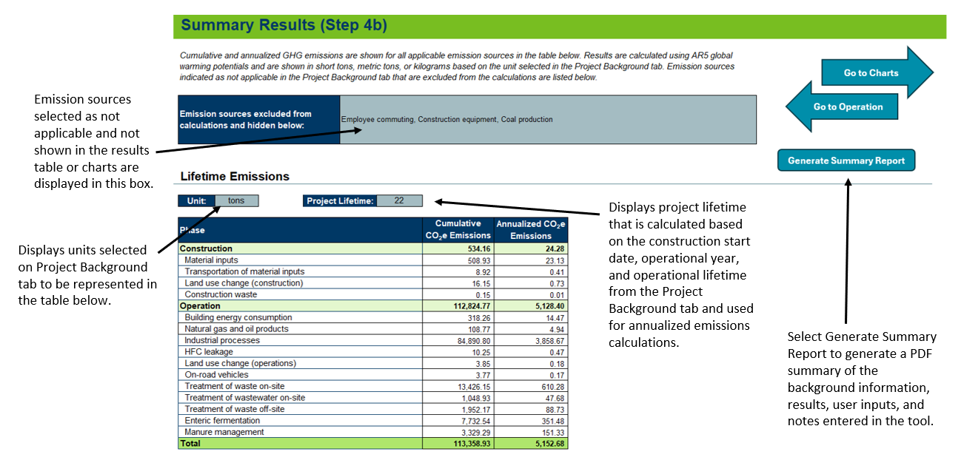
Summary Report: This report includes a summary of the background information provided by users, the cumulative and annualized emissions by source and project phase, user inputs for each emissions source, and any notes entered on the Notes tab. NA is used to denote emissions that were not quantified and/or activity was identified as not applicable by the user. An example excerpt of this report is provided in Figure D-13. Users may amend this report to their EAW as part of their report to Item 18.
Figure D-13. Example Summary Report Excerpt
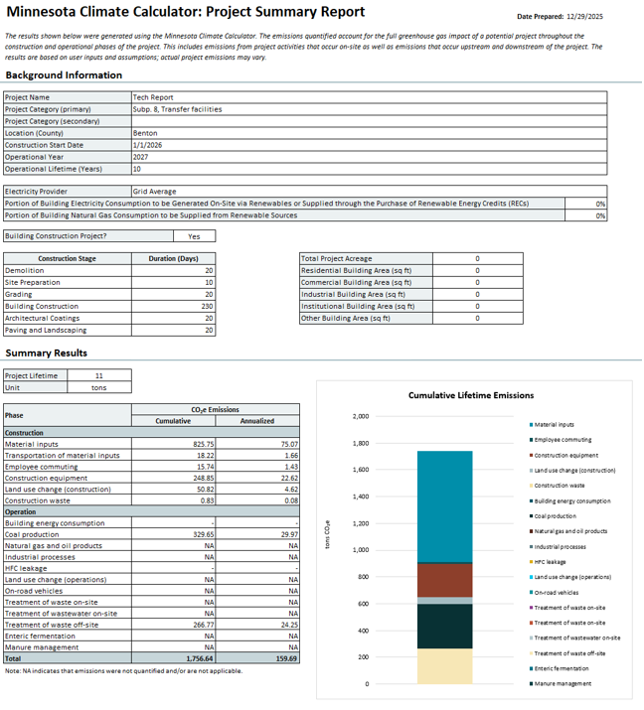
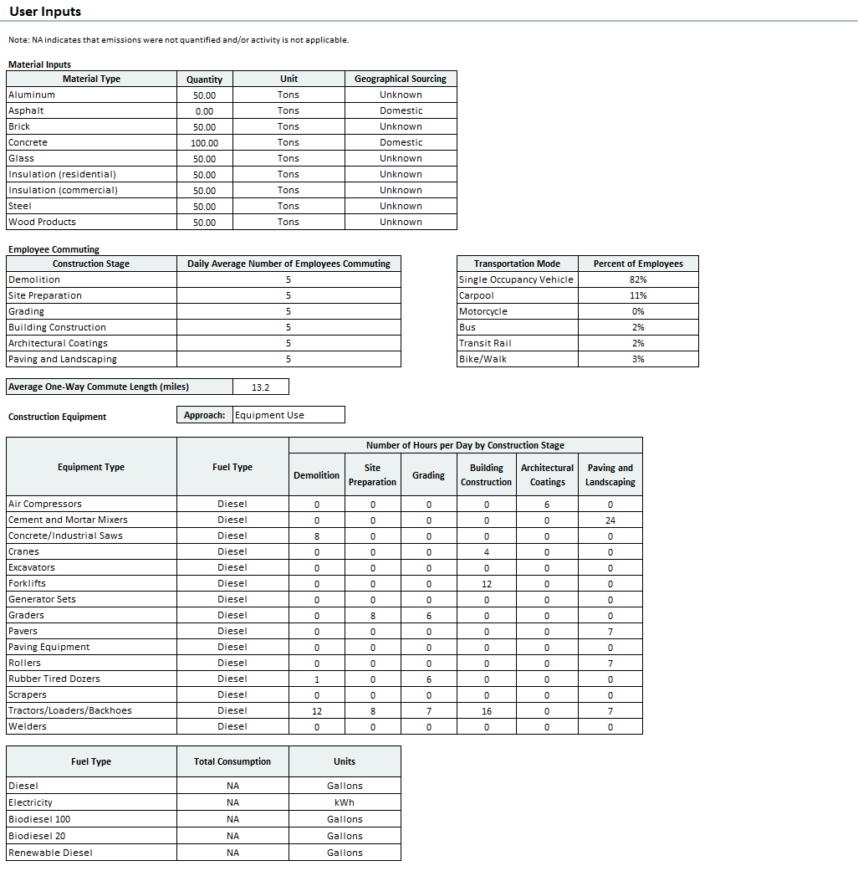
Emissions Equivalencies: Emissions equivalencies for cumulative and annualized emissions are shown underneath the results table, derived using equivalency factors from EPA’s Greenhouse Gas Equivalency Calculator. For cumulative emissions results, equivalencies are shown for miles driven by an average gasoline-powered passenger vehicle, gallons of gasoline consumed, and tons of waste recycled instead of landfilled. For annualized emissions results, equivalencies are shown for gasoline-powered passenger vehicles driven for one year, home energy use for one year, and acres of U.S. forests in one year. Users may also follow the link provided to convert emissions results into additional equivalencies.
Charts: Results are also displayed graphically on the Charts tab. Lifetime emissions are represented as stacked bar charts, to show cumulative and annualized lifetime emissions by emission source. Emissions by project phase are represented as clustered column charts. Non-applicable emission sources are automatically hidden from view in the charts.

- Mitigation and Adaptation

Mitigation Tab
The Mitigation tab identifies potential mitigation measures that may be used to reduce GHG emissions from the proposed project. A unique identifier (e.g., M-1A-1) is assigned to each identified mitigation measure in the calculator. While some measures may reduce emissions across more than one source, the calculator categorizes each measure according to the primary source through which emission reductions are expected. Users can use the column filters to narrow the list of measures to only those emission sources applicable to their project. Once the measure list is filtered, users should carefully review the measure descriptions to determine which measures are most applicable to their project and support their GHG reduction goals. Users can then use the drop-down menu under the Select column to choose the measures they intend to implement as part of their project.
Select measures are available for quantification. The ‘Quantifiable?’ column identifies which measures are available for quantification in the ‘Quantified Reductions’ tab. Users can click the ‘Select Applicable Quantifiable Measures’ button to select quantifiable mitigation measures that are deemed applicable based on entered user inputs. Users can also select the ‘Select All Unhidden Measures’ button to select “Yes” for all visible measures. Rows are shaded gray when a measured is selected. The ‘Reset all Selected Measures’ button can be used to remove all selections from the first column. The ‘Generate PDF’ button can be used to print a PDF of all visible measures. Figure D-14 highlights the features of the Mitigation tab.
Figure D-14. Example Mitigation Measure
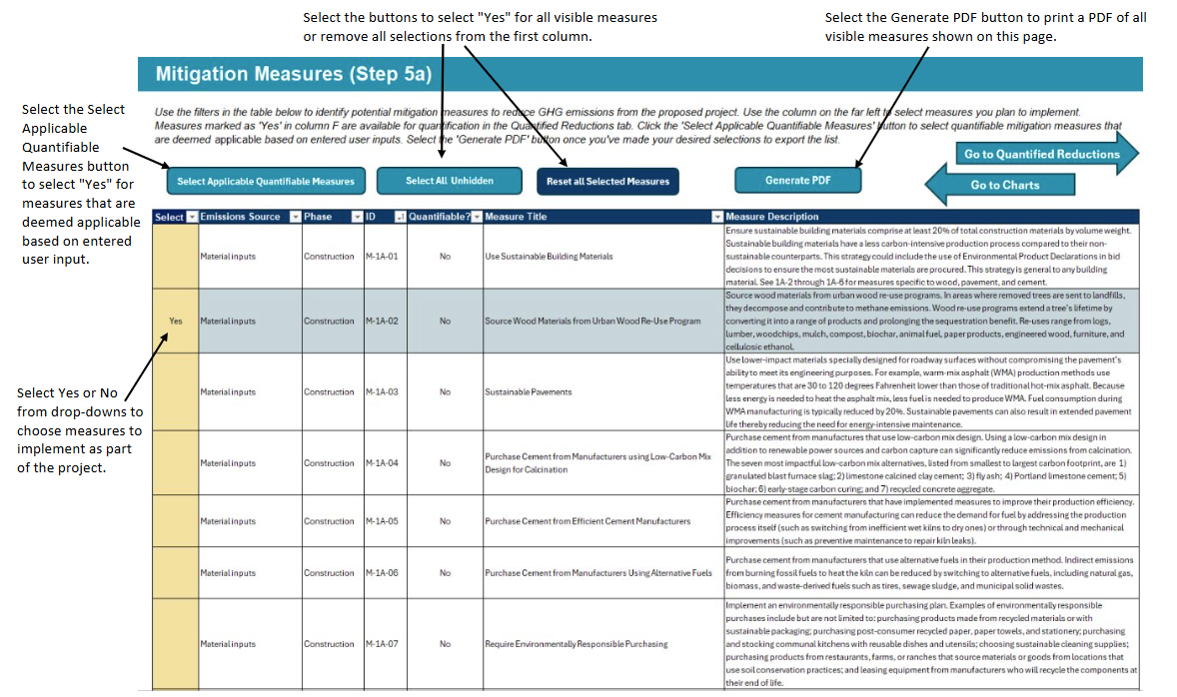

Quantified Reductions
The Quantified Reductions tab quantifies GHG emission reductions from the user-select mitigation measures in the Mitigation tab. Reductions are quantified based on data entered in the Project Background and User Inputs tabs, as well as methods and assumptions used throughout the calculator. In some cases, additional data inputs are required to quantify reductions. For these cases, users should enter data into the yellow cells to quantify reductions from these measures. Emissions from the Baseline and Mitigation Scenarios, as well as total mitigated emissions, are shown for all selected measures in the summary table and graphic at the top of the tab. The ‘Generate PDF’ button can be used to print a PDF of the tab. Figure D-15 highlights the features of the Quantified Reductions tab.
Figure D-15. Example Quantified Reductions
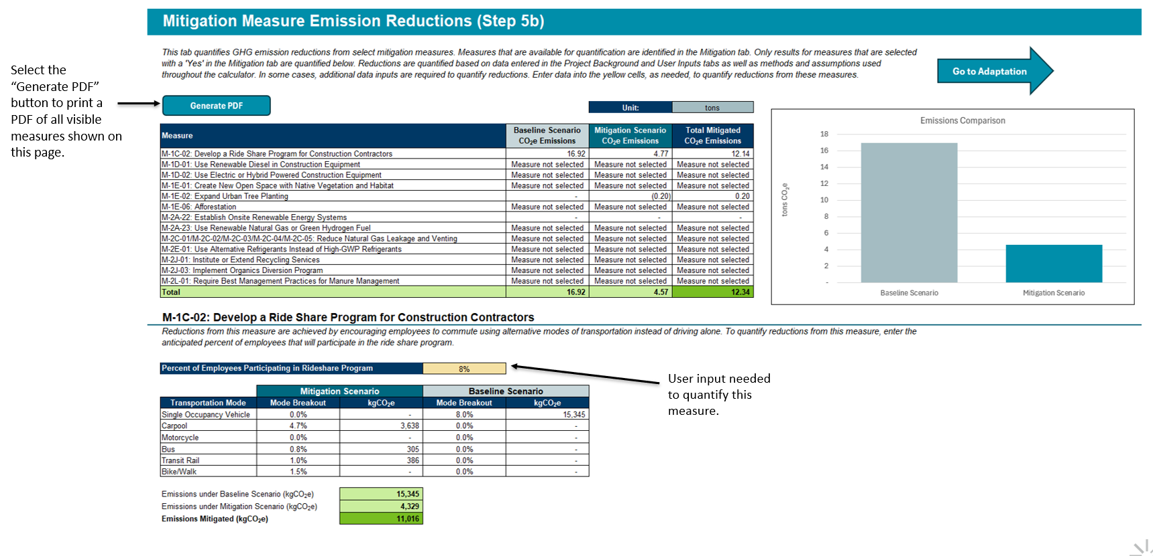

Adaptation Tab
The Adaptation tab identifies adaptation strategies that can be applied by project developers to adapt to changing climate conditions. A unique identifier (e.g., S-1A-1) is assigned to each identified adaptation strategy in the calculator. The strategies are mapped to a defined list of climate trends and project characteristics. Strategies may map to more than climate trend and/or project characteristic. Users can filter relevant adaptation strategies by selecting or unselecting relevant climate trends and project characteristics in the check boxes under Steps 1 and 2. The table automatically filters based on these selections. Users can then use the drop-down menu under the Select column to choose the strategies they intend to implement as part of their project. Users can also select the ‘Select All Unhidden Strategies’ button to select “Yes” for all visible strategies. Rows are shaded gray when a strategy is selected. The ‘Reset all Selected Strategies’ button can be used to remove all selections from the first column. The ‘Reset Climate Trends’ and ‘Reset Project Characteristics’ buttons may also be used to select all climate trends and project characteristics in the check boxes under Steps 1 and 2. The ‘Generate PDF’ button may be selected to print a PDF of all visible strategies. Figure D-16 highlights the features of the adaptation tab.
Figure D-16. Example Adaptation Strategies
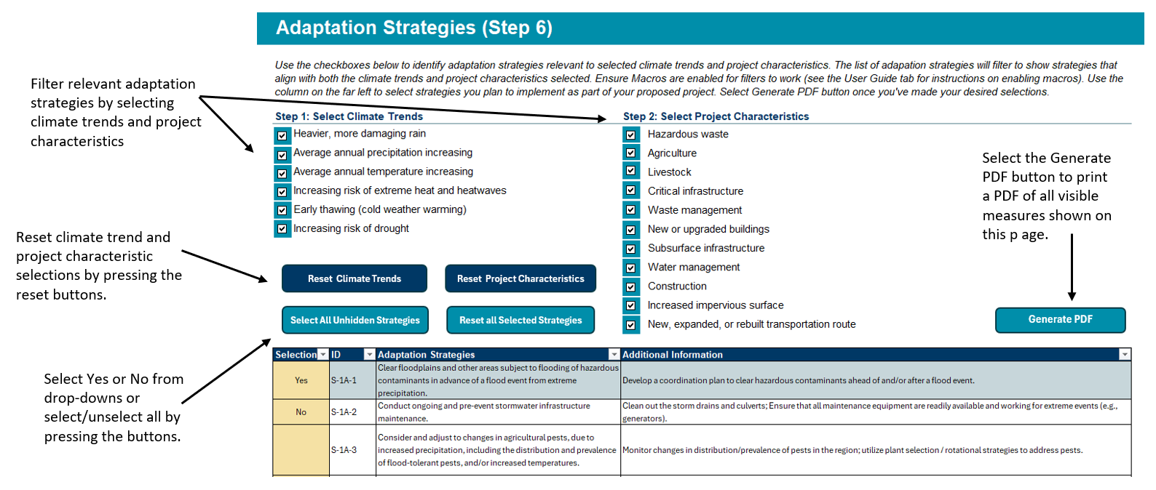

EPA. “Greenhouse Gas Equivalencies Calculator – Calculations and References,” 2024. https://www.epa.gov/energy/greenhouse-gas-equivalencies-calculator-calculations-and-references.

